Physics 30 1998 January

Use the following information to answer the next three questions.

A physics student is investigating the conservation of mechanical energy in a system consisting of a massless, frictionless pulley and two blocks suspended by string. The student determines the potential energy with respect to ground level.
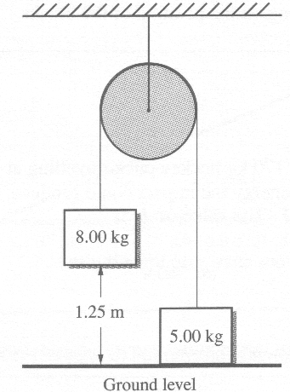

- The initial total mechanical energy in this system is
A. 159 J
B. 98.1 J
C. 36.8 J
D. 0 J

- Which of the following statements describes what happens when the blocks in the system are released?
A. The 8.00 kg block gains potential energy and loses kinetic energy.
B. The 8.00 kg block gains potential energy and gains kinetic energy.
C. The 5.00 kg block gains potential energy and loses kinetic energy.
D. The 5.00 kg block gains potential energy and gains kinetic energy.

- While the blocks are moving, the total mechanical energy
A. increases
B. decreases
C. remains constant
D. varies, depending on the position of the blocks
____________________________

Numerical Response

- A goalie catches a 0.170 kg hockey puck travelling at a speed of 35.0 m/s. The maximum heat energy the impact could produce, expressed in scientific notation, is b x 10^{w} J. The value of b is __________.

(Record your three-digit answer in the numerical-response section on the answer sheet.)

Use the following information to answer the next two questions.

A particle with a mass of 3.60 x l0⁻¹⁸ kg acquires 3.00 x 10⁵ eV of kinetic energy when it accelerates from rest through a potential difference of 1.00 x 10⁴ V.

- The charge on the particle is
A. 4.80 x 10⁻¹⁸ C
B. 3.33 x 10⁻² C
C. 3.00 x 10¹ C
D. 2.08 x 10¹⁷ C

Numerical Response

- The speed that the particle acquires, expressed in scientific notation, is b x 10^{w} m/s. The value of b is __________.

(Record your three-digit answer in the numerical-response section on the answer sheet.)

Use the following information to answer the next three questions.

Potential Difference versus Plate Separation for Parallel Plates
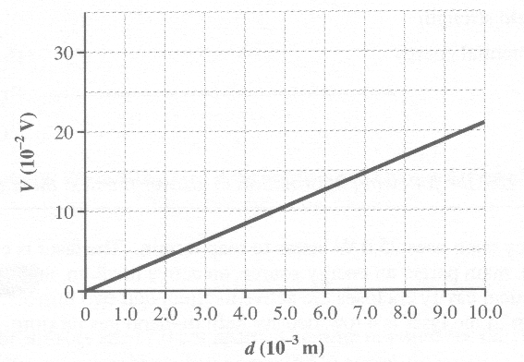

- The rate of change of potential difference with respect to the plate separation (d), in SI units, is
A. 0.048
B. 0.48
C. 2.1
D. 21

- The proper SI units for the slope of the line on the graph are
A. J/m
B. V/m
C. V/s
D. N/s

- The physical quantity that the slope represents is the electric
A. force
B. power
C. field strength
D. potential energy
____________________________

Use the following information to answer the next three questions.

A survey team uses 25.0 W lasers to map terrain. The laser is composed of three main parts: an energy source, an active medium, and an optical cavity. The optical cavity encloses the active medium and two mirrors. The active medium in the laser is a low-density helium-neon gas mixture.
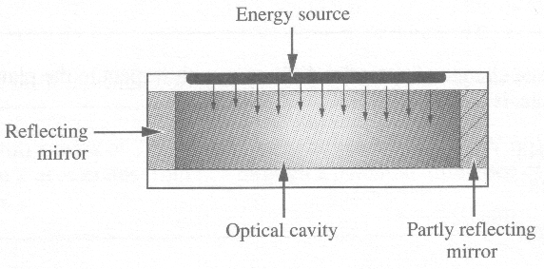

- The 25.0 W laser is only 0.0200% efficient in converting electric energy into photon energy. The output power of the laser is
A. 5.00 x 10⁻³ W
B. 8.00 x 10⁻³ W
C. 1.25 x 10³ W
D. 3.14 x 10⁴ W

Use your recorded answer from Multiple Choice 8 to answer Multiple Choice 9.*

- The beam of light from the laser has a wavelength of 633 nm. The number of photons per second emitted by the laser is
A. 9.99 x 10²²
B. 3.99 x 10²¹
C. 2.55 x 10¹⁶
D. 1.59 x 10¹⁶

*You can receive marks for this question even if the previous question was answered incorrectly.

Numerical Response

- In this laser, the mirrors are 17.0 cm apart. The time required for the photons to travel from one mirror to the other, expressed in scientific notation, is b x 10^{-w} s. The value of b is __________.

(Record your three-digit answer in the numerical-response section on the answer sheet.)

____________________________

- Scientists believe that chemical compounds found in far regions of space are the same as those found on Earth. Evidence for this has been provided in studies of
A. spectra
B. electricity
C. gravitation
D. magnetism

Use the following information to answer the next three questions.

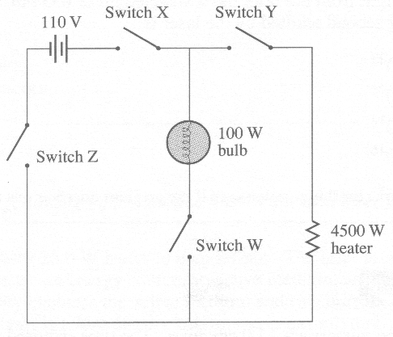

- An electric heater radiates energy at a rate of 4500 W when operated at a potential difference of 110 V. The resistance of the heater element is
A. 2.44 x 10⁻² Ω
B. 3.72 x l0⁻¹ Ω
C. 2.69 Ω
D. 4.09 x 10¹ Ω

- The switch that controls only the heater is labelled as
A. W
B. X
C. Y
D. Z

Numerical Response

- When the 100 W bulb is lit, the current in the bulb, expressed in scientific notation, is b x 10^{-w} A. The value of b is __________.

(Record your three-digit answer in the numerical-response section on the answer sheet.)

Use the following information to answer the next question.

A straight wire moves at a speed of 15.0 m/s at right angles to a magnetic field, as shown in the diagram. The wire is 32.6 cm long, and the magnitude of the magnetic field is 0.253 T.
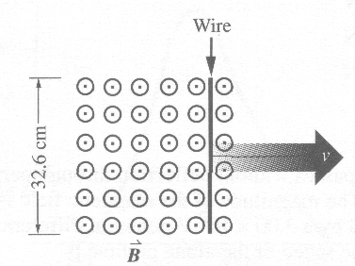

Numerical Response

- The potential difference between the ends of the wire is __________ V.

(Record your three-digit answer in the numerical-response section on the answer sheet.)

_____________________________

- A transformer is used to change
A. alternating current to alternating current of a different magnitude
B. alternating current to constant direct current of the same magnitude
C. constant direct current to constant direct current of a different magnitude
D. constant direct current to alternating current of the same magnitude

- Which of the following is an example of electromagnetic induction?
A. The forces two current-carrying wires exert on each other
B. The magnetic field produced by a constant current in a wire
C. The forces a magnet and a current-carrying wire exert on each other
D. The current produced in a wire loop by a changing magnetic field

- A particle with a charge of 3.0 x 10⁻¹² C moves with a speed of 2.0 x 10² m/s at right angles to a magnetic field. The strength of the magnetic field is 0.400 T. The magnitude of the force acting on the particle due to the field is
A. 4.8 x 10⁻⁸ N
B. 2.4 x 10⁻¹⁰ N
C. 1.5 x 10⁻¹³ N
D. 1.3 x 10⁻¹⁷ N

- An alpha particle passes without deflection through perpendicular electric and magnetic fields. The magnitude of the magnetic field is 2.20 x 10⁻² T. The electric field is maintained by a 3.00 x 10² V potential difference across plates that are 4.00 cm apart. The speed of the alpha particle is
A. 7.50 x 10³ m/s
B. 1.36 x 10⁴ m/s
C. 1.20 x 10⁵ m/s
D. 3.41 x 10⁵ m/s

Use the following information to answer the next question.

The relative sensitivity of a normal human eye to radiant energy of fixed intensity is illustrated in the graph below.
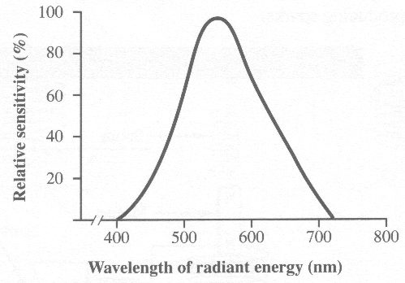

- The normal human eye shows the greatest sensitivity to
A. ultraviolet light
B. green light
C. violet light
D. red light
_________________________________

- There is a relationship between the direction of propagation of an electromagnetic wave and the directions of its electric and magnetic fields. In this relationship, the electric and magnetic fields are
A. parallel to each other and parallel to the direction of propagation
B. parallel to each other and perpendicular to the direction of propagation
C. perpendicular to each other and parallel to the direction of propagation
D. perpendicular to each other and perpendicular to the direction of propagation

Use the following information to answer the next three questions.

Side View of an Electromagnetic Apparatus

During his studies of electromagnetism, a student proposes the following method of producing sparks.
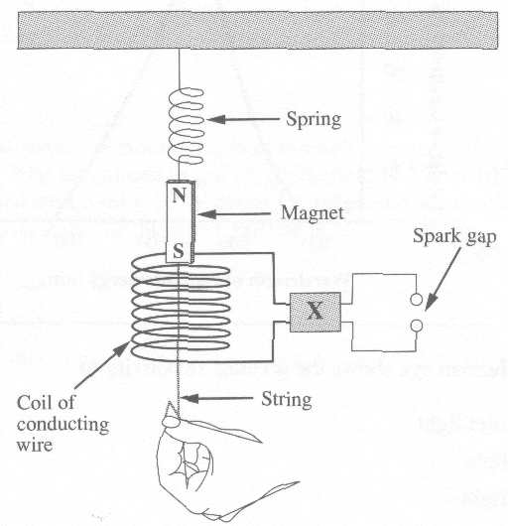
The student pulls down on the string and then releases it, causing the magnet to oscillate. As the magnet moves downward and enters the coil from above, a current is induced in the coil.

- To increase the voltage across the spark gap, which of the following components should be connected at X?
A. A resistor
B. A transformer
C. A slip-ring commutator
D. A split-ring commutator

- Which of the following diagrams shows the direction of the magnetic field generated by the induced current in the coil as the magnet moves downward into the top of the coil?
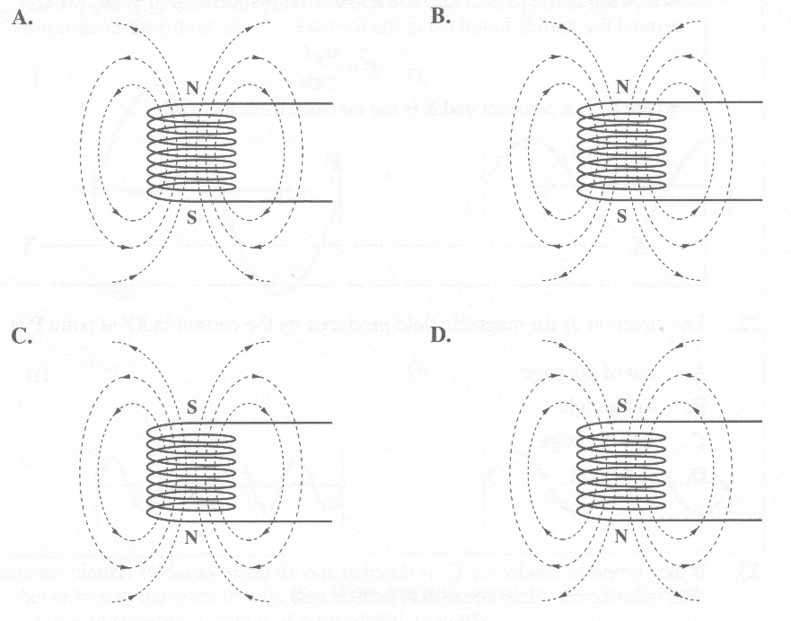

- If the effective voltage induced in the coil of conducting wire is 0.0500 V AC, the maximum induced voltage is
A. 0.0354 V
B. 0.0707 V
C. 0.100 V
D. 0.0250 V

Use the following information to answer the next two questions.

XY represents a section of a current-carrying wire. Conventional current is flowing in the direction of the arrow. The magnetic field at any point around the wire is found using the formula
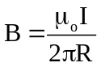
where μ_{o} is a constant and R is the distance from the wire.
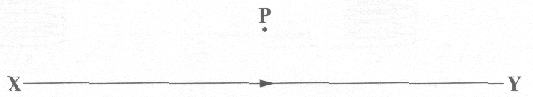

- The direction of the magnetic field produced by the current in XY at point P is
A. out of the page
B. to the right
C. into the page
D. to the left

- If the current in conductor XY is doubled and all other variables remain constant, then the magnetic field strength at point P will
A. decrease to one-half of its present value
B. remain at its present value
C. increase to double its present value
D. increase to four times its present value

Use the following information to answer the next question.

Electromagnetic waves can be represented by the graphs of their electric fields. The following graphs represent the electric field of four electromagnetic waves over a fixed time interval.
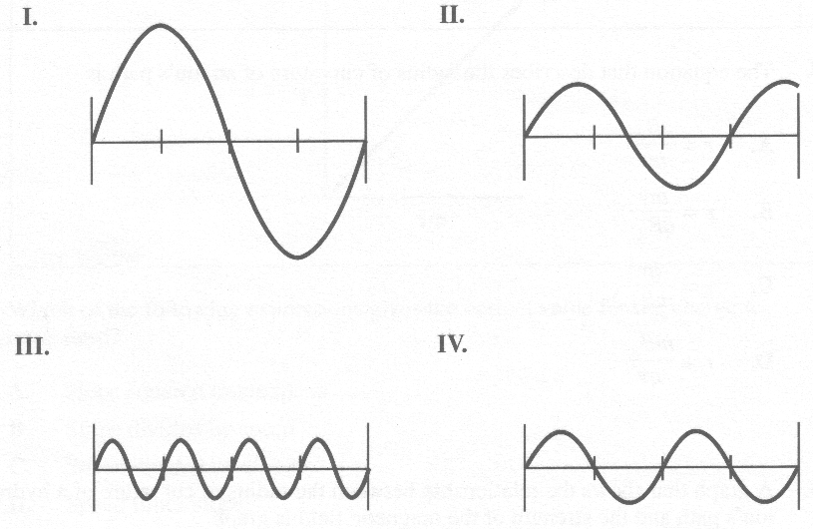

- According to quantum theory, the electromagnetic wave that has the greatest amount of energy per photon is represented by graph
A. I
B. II
C. III
D. IV

Use the following information to answer the next three questions.

An experiment is designed to study the charge to mass ratio of hydrogen ions. Hydrogen ions, all moving in the same direction and with the same speed, v, are injected into a mass spectrometer. The magnitude of the magnetic field is varied, and the resulting radii of the path of the hydrogen ions are measured.

- The equation that describes the radius of curvature of an ion's path is
A. 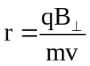
B. 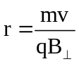
C. 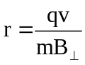
D. 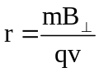

- A graph that shows the relationship between the radius of curvature of a hydrogen ion's path and the strength of the magnetic field is graph
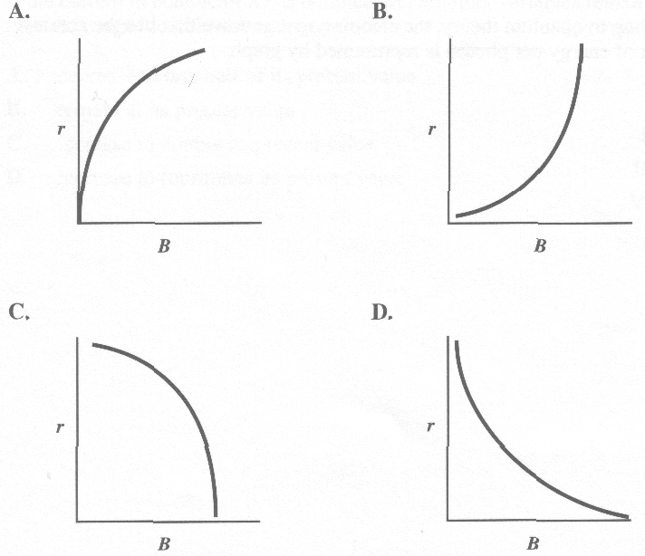

Use the following additional information to answer the next question.

The manipulated variable in this experiment was modified in order to obtain the straight line graph shown below. The slope of this straight line graph can be used to determine the charge to mass ratio of a hydrogen ion.
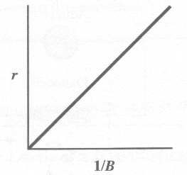

- Which of the following expressions gives the correct value for the charge to mass ratio?
A. Slope squared times speed
B. Slope divided by speed
C. Speed divided by slope
D. Speed times slope

Use the following information to answer the next question.

A student made the following statements with respect to infrared rays, microwaves, and ultraviolet light.

I. They all exhibit diffraction.
II. They all exhibit interference.
III. They all have the same frequency in a vacuum.
IV. They all have a speed of 3.00 x 10⁸ m/s in a vacuum.

- The statement made by the student that is incorrect is
A. I
B. II
C. III
D. IV

Use the following information to answer the next three questions.

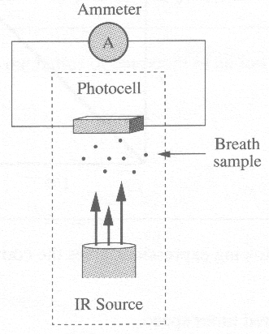
One type of breathalyzer involves illuminating a photocell (photoelectric surface) with infrared (IR) radiation of wavelength 9.50 x 10⁻⁶ m. Alcohol molecules absorb infrared radiation. A breathalyzer circuit is illustrated below.

The ammeter in the breathalyzer is calibrated to register a maximum reading with no alcohol sample between the detector and the IR source.

- A breath sample containing alcohol is introduced into the analyzer. If it absorbs 50% of the radiation emitted by the infrared source, the current in the ammeter will be
A. halved
B. doubled
C. the same
D. quartered

Numerical Response

- A current of 4.71 x 10⁻³ A passes through the ammeter for 30.2 s. The number of electrons that pass through the ammeter in that time, expressed in scientific notation, is a.b x 10^{cd}. The values of a, b, c, and d are _____, _____, _____, and _____ .

(Record all four digits in the numerical-response section on the answer sheet.)

Numerical Response

- The energy of a photon of infrared radiation from this source, expressed in scientific notation, is b x 10^{-w} J. The value of b is _________.

(Record your three-digit answer in the numerical-response section on the answer sheet.)

____________________________

Use the following information to answer the next question.

Energy Levels of a Hypothetical Atom
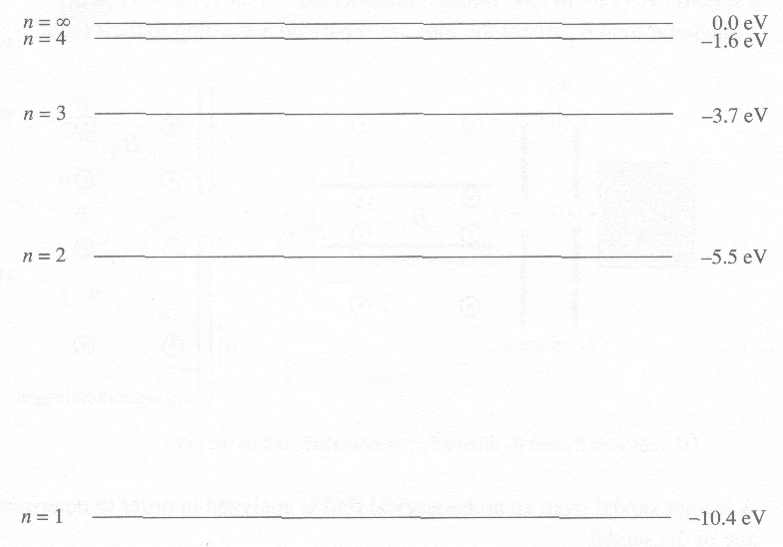

Numerical Response

- The energy required to ionize this atom when the electron is in the second energy level is _________ eV.

(Record your two-digit answer in the numerical-response section on the answer sheet.)

Use the following information to answer the next three questions.

Carbon Dating Using a Mass Spectrometer

One method of determining the age of archeological remains is carbon dating. Of all carbon isotopes present in living tissue, 1.66 x 10⁻¹⁰ % are carbon-14. The radioactive half-life of carbon-14 is 5.73 x 10³ years. A mass spectrometer is a device that separates ions of different masses and can be used to determine the percentage of carbon-14 present in a sample.

In a mass spectrometer, a source produces gaseous ions that are accelerated by two vertical parallel plates that have a large potential difference between them. The beam of ions enters a velocity selector that allows only those ions with a specific velocity to pass through undeflected. Finally, the ions enter a magnetic field B₂ where the ions are separated according to their mass.
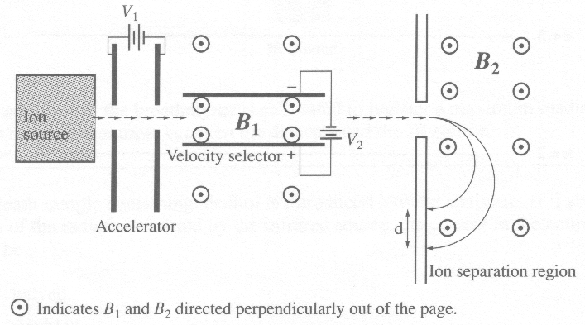

A leather sandal from an archeological find is analyzed in order to determine the age of the sandal.

- In the leather sandal, the mass spectrometer measures the carbon-14 content as 8.30 x 10⁻¹¹ % of all carbon isotopes present. The approximate age of the sandal is
A. 1.43 x 10³ years
B. 5.73 x 10³ years
C. 1.15 x 10⁴ years
D. 2.29 x 10⁴ years

Numerical Response

- The carbon atoms in the sandal are ionized by high-energy photons in the source chamber of the mass spectrometer. The ionization energy of carbon is 11.3 eV. The minimum frequency of radiation required in the source, expressed in scientific notation, is b x 10^{w} Hz. The value of b is _________.

(Record your three-digit answer in the numerical-response section on the answer sheet.)

- The horizontal speed of the stream of carbon ions through the velocity selector is given by the expression
A. 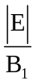
B. 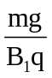
C. 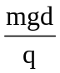
D. 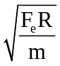

Use the following information to answer the next two questions.

In an experiment, a researcher studied the decay of 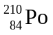 which decays by alpha emission and releases a stable 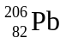 atom. The half-life of is 138.4 days. The mass of the sample of at the start of the experiment was 34.0 g.

Numerical Response

- The amount of remaining after 415.2 days was _________ g.

(Record your three-digit answer in the numerical-response section on the answer sheet.)

Numerical Response

- At the end of the experiment, the amount of remaining was 1.06 g. The duration of the experiment was __________ days.

(Record your three-digit answer in the numerical-response section on the answer sheet.)

- The wavelength of the photon emitted when the electron of a hydrogen atom makes a transition from the third energy level to the first energy level is
A. 1.0 x 10⁻⁷ m
B. 2.5 x 10⁻⁷ m
C. 5.5 x 10⁻⁷ m
D. 8.3 x 10⁻⁷ m

- Experiments with cathode ray tubes led to the discovery of the
A. photon
B. neutron
C. electron
D. alpha particle

- An oil drop with a mass of 5.74 x 10⁻¹⁶ kg is suspended between two horizontal parallel plates. The magnitude of the electric field between the plates is 5.00 x 10³ N/C. The magnitude of the charge on the drop is
A. 8.00 x 10⁻¹⁶ C
B. 1.13 x 10⁻¹⁸ C
C. 1.60 x 10⁻¹⁹ C
D. 1.15 x 10⁻¹⁹ C

- A metal has a work function of 4.6 eV. The corresponding threshold frequency is
A. 6.9 x 10³³ Hz
B. 1.1 x 10¹⁵ Hz
C. 9.0 x 10⁻¹⁶ Hz
D. 1.4 x 10⁻³⁴ Hz

Use the following information to answer the next question.

Photoelectric Effect
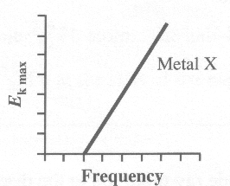

This graph shows the relationship between the maximum kinetic energy for emitted photoelectrons and the frequency of incident light for Metal X.

Note: The five graphs in this question are drawn to the same scale.

- Metal Y has a different work function from Metal X. The graph that could represent the relationship between the maximum kinetic energy for emitted photoelectrons and the frequency of incident light for Metal Y is
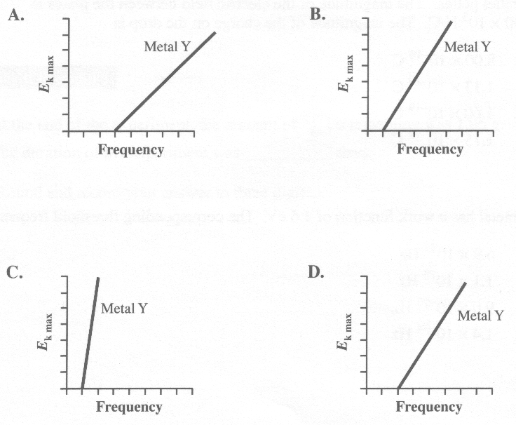

- The element 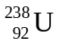 undergoes radioactive decay until it attains a stable state . The first four stages of this decay series are

The particles emitted in each of these steps are, respectively,

A. alpha, beta, beta, alpha
B. beta, alpha, alpha, beta
C. alpha, gamma, gamma, alpha
D. gamma, alpha, alpha, gamma

Numerical Response

- The minimum potential difference through which an electron must be accelerated to produce an X-ray of energy 1.62 x 10⁴ eV, expressed in scientific notation, is b x 10^{w} V. The value of b is ________.

(Record your three-digit answer in the numerical-response section on the answer sheet.)

Use the following information to answer the next question.

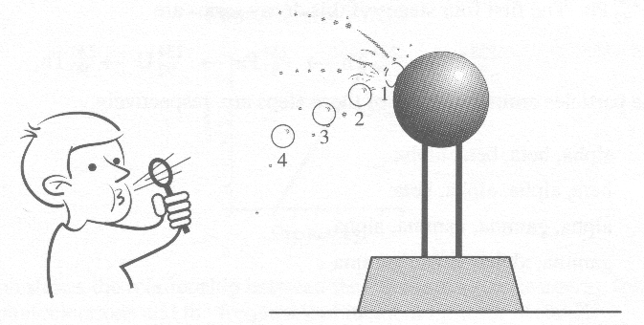
In a classroom demonstration, the dome of a Van de Graaff generator was initially charged negatively. A stream of closely spaced neutral soap bubbles was blown toward the dome of the generator. Much to the surprise of the teacher and the students, the following observations were made:

• the bubbles were initially attracted to the top of the dome of the generator until the first bubble hit the dome
• the first bubble hit the dome and splattered into hundreds of tiny droplets that sprayed everywhere
• all the other bubbles then stopped in mid-air
• the other bubbles were then repelled from the dome of the generator and from each other

Using the concepts of electrostatic forces and charge distribution, explain

• Why the soap bubbles were initially attracted to the top of the generator

• Why, after the first soap bubble splattered, the other bubbles were repelled from the generator and from each other

A diagram or diagrams may help to clearly communicate your ideas.

2. A compact car with a mass of 1.0 x 10³ kg is moving at 10 m/s north along a single-lane road. At the same time, a full-size car with a mass of 2.0 x 10³ kg is moving at 8.0 m/s south along the same road. The two cars collide head-on. Immediately after the collision, the compact car has a velocity of 4.0 m/s south. The interaction lasted 8.0 x 10⁻² s.

• Determine the speed and direction of the full-size car immediately after the collision.

• Show that the collision was not elastic.

• Determine the magnitudes and the directions of the average forces of impact on the compact car and on the full-size car.

